**Data Dictionary for John_clean2.sas7bdat**

| **Variable Position** | **Variable Name** | **Variable Type** | **Variable Length** | **Variable**  **Format** | **Variable Label** | **Variable Values** |
| --- | --- | --- | --- | --- | --- | --- |
| 1 | study_ID | Num | 8 |  | ID number |  |
| 2 | age | Num | 8 |  | Age(years) |  |
| 3 | lifetime_aab | Num | 8 | LIFEF. | Lifetime alcohol abstinence (Y/N) | 0=0-Yes:ever drinker || 1=1-No:lifetime abstained |
| 4 | female | Num | 8 |  | Female(Y/N) |  |
| 5 | edu | Num | 8 | EDUF. | Education Category | 1=1-<10 years || 2=2-10-11 years || 3=3->11 years |
| 6 | age_grp | Num | 8 | AGEF. | Age Category | 1=1-18-39 || 2=2-40-49 || 3=3-50-64 |
| 7 | death_status | Char | 8 |  | Death Status |  |
| 8 | mort | Num | 8 |  | Total Mortality(Y/N) |  |
| 9 | futime | Num | 8 |  | Follow-up time (days) |  |
| 10 | health | Num | 8 | HEALTHF. | Self-reported health status | 1=1-Very good to Excellent || 2=2-Good || 3=3-Fair to poor |
| 11 | COD | Num | 8 | CODF. | Cause of Death | 1=Cardiovascular || 2=Cancer || 3=Gastrointestinal || 4=Acute || 5=Psychiatric 6=Unknown || 7=without TB |
| 12 | CVD_mort | Num | 8 |  | Cardiovascular Cause of Death(Y/N) |  |
| 13 | CA_mort | Num | 8 |  | Cancer Cause of Death (Y/N) |  |
| 14 | alc_cons | Num | 8 | CONSF. | Alcohol Consumption Group | 1=Low to Moderate (AUDIT-C=1-3) || 2=Moderate to High (AUDIT-C=4) 3=High (AUDIT-C=5) || 4=Very high (AUDIT-C=6-7) 5=Abstinent (AUDIT-C=0) || 6=Extremely high (AUDIT-C=8-12) |
| 15 | Smoke | Num | 8 | SMKF. | Smoker Status | 0=Never smoker || 1=Ever less than daily || 2=Former daily 3=Current daily <20 cpd || 4=Current daily >=20 cpd |

**Codebook for John_clean2.sas7bdat**

| Variable | Label | | N | | N Miss | | Mean | Std Dev | | Minimum | | 25th Pctl | | | 50th Pctl | 75th Pctl | Maximum |
| --- | --- | --- | --- | --- | --- | --- | --- | --- | --- | --- | --- | --- | --- | --- | --- | --- | --- |
| **study_ID** | **ID number** | | 4028 | | 0 | | 2014.5 | 1162.93 | | 1 | | 1007.5 | | | 2014.5 | 3021.5 | 4028 |
|  |  | |  | |  | |  |  | |  | |  | | |  |  |  |
| Variable | Label | | N | | N Miss | | Mean | Std Dev | | Minimum | | 25th Pctl | | | 50th Pctl | 75th Pctl | Maximum |
| **age** | **Age(years)** | | 4028 | | 0 | | 41.72 | 12.88 | | 17 | | 31 | | | 41 | 54 | 64 |
|  | | Histogram for age  **Lifetime alcohol abstinence (Y/N)** 0=0-Yes:ever drinker || 1=1-No:lifetime abstained | | | | | | | | | | |
|  | | **lifetime_aab** | | Frequency | | Percent | | | Cumulative Frequency | | Cumulative Percent | |
|  | |  |
|  | | 0 | | 3984 | | 98.91 | | | 3984 | | 98.91 | |  |
|  | | 1 | | 44 | | 1.09 | | | 4028 | | 100 | |  |
|  | |  | |  | |  | | |  | |  | |  |
|  | | **Female(Y/N)** | | | | | | | | | | |  |
|  | | **female** | | Frequency | | Percent | | | Cumulative Frequency | | Cumulative Percent | |  |
|  | |  |
|  | | 0 | | 2022 | | 50.2 | | | 2022 | | 50.2 | |  |
|  | | 1 | | 2006 | | 49.8 | | | 4028 | | 100 | |  |
|  | |  | |  | |  | | |  | |  | |  |
|  | | **Education Category**  1=1-<10 years || 2=2-10-11 years || 3=3->11 years | | | | | | | | | | |  |
|  | | **edu** | | Frequency | | Percent | | | Cumulative Frequency | | Cumulative Percent | |  |
|  | |  |
|  | | 1 | | 1927 | | 47.84 | | | 1927 | | 47.84 | |  |
|  | | 2 | | 1471 | | 36.52 | | | 3398 | | 84.36 | |  |
|  | | 3 | | 630 | | 15.64 | | | 4028 | | 100 | |  |
|  | |  | |  | |  | | |  | |  | |  |
|  | | **Age Category** 1=1-18-39 || 2=2-40-49 || 3=3-50-64 | | | | | | | | | | |  |
|  | | **age_grp** | | Frequency | | Percent | | | Cumulative Frequency | | Cumulative Percent | |  |
|  | |  |
|  | | 1 | | 1851 | | 45.95 | | | 1851 | | 45.95 | |  |
|  | | 2 | | 847 | | 21.03 | | | 2698 | | 66.98 | |  |
|  | | 3 | | 1330 | | 33.02 | | | 4028 | | 100 | |  |
|  | |  | |  | |  | | |  | |  | |  |
|  | | **Death Status** | | | | | | | | | | |  |
|  | | **death_status** | | Frequency | | Percent | | | Cumulative Frequency | | Cumulative Percent | |  |
|  | |  |
|  | | alive | | 3455 | | 85.77 | | | 3455 | | 85.77 | |  |
|  | | deceased | | 573 | | 14.23 | | | 4028 | | 100 | |  |
|  | |  | |  | |  | | |  | |  | |  |
|  | | **Total Mortality(Y/N)** | | | | | | | | | | |  |
|  | | **mort** | | Frequency | | Percent | | | Cumulative Frequency | | Cumulative Percent | |  |
|  | |  |
|  | | 0 | | 3455 | | 85.77 | | | 3455 | | 85.77 | |  |
|  | | 1 | | 573 | | 14.23 | | | 4028 | | 100 | |  |

| Variable | Label | N | N Miss | Mean | Std Dev | Minimum | 25th Pctl | 50th Pctl | 75th Pctl | Maximum |
| --- | --- | --- | --- | --- | --- | --- | --- | --- | --- | --- |
| **futime** | **Follow-up time (days)** | 4028 | 0 | 7540.13 | 1449.02 | 151 | 8035 | 8035 | 8035 | 8035 |

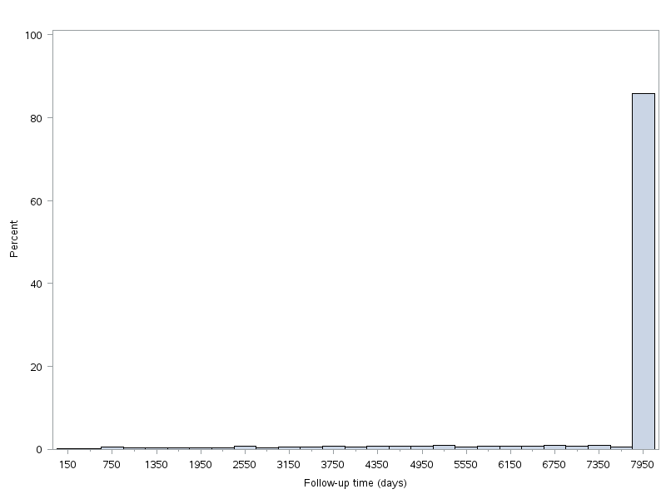

| **Self-reported health status** 1=1-Very good to Excellent || 2=2-Good || 3=3-Fair to poor | | | | |  | |
| --- | --- | --- | --- | --- | --- | --- |
| **Health** | Frequency | Percent | Cumulative Frequency | Cumulative Percent |  | |
|  |  | |
| 1 | 1427 | 35.43 | 1427 | 35.43 |  |  | |
| 2 | 1926 | 47.82 | 3353 | 83.24 |  |  | |
| 3 | 675 | 16.76 | 4028 | 100 |  |  | |
|  |  |  |  |  |  |  | |
| **Cause of Death** 1=Cardiovascular || 2=Cancer || 3=Gastrointestinal || 4=Acute || 5=Psychiatric 6=Unknown || 7=without TB | | | | | | | |
| **COD** | Frequency | Percent | Cumulative Frequency | Cumulative Percent | Percent, without missing | Cumulative Percent, without missing | |
| . | 3455 | 85.77 | 3455 | 85.77 |  |  | |
| 1 | 234 | 5.81 | 3689 | 91.58 | 40.84 | 40.84 | |
| 2 | 241 | 5.98 | 3930 | 97.57 | 42.06 | 82.9 | |
| 3 | 35 | 0.87 | 3965 | 98.44 | 6.11 | 89.01 | |
| 4 | 15 | 0.37 | 3980 | 98.81 | 2.62 | 91.62 | |
| 5 | 5 | 0.12 | 3985 | 98.93 | 0.87 | 92.5 | |
| 6 | 14 | 0.35 | 3999 | 99.28 | 2.44 | 94.94 | |
| 7 | 29 | 0.72 | 4028 | 100 | 5.06 | 100 | |
|  |  |  |  |  |  |  | |
| **Cardiovascular Cause of Death(Y/N)\*** | | | | | | | |
| **CVD_mort** | Frequency | Percent | Cumulative Frequency | Cumulative Percent | Percent, without missing | Cumulative Percent, without missing | |
| . | 339 | 8.42 | 339 | 8.42 |  |  | |
| 0 | 3455 | 85.77 | 3794 | 94.19 | 93.66 | 93.66 | |
| 1 | 234 | 5.81 | 4028 | 100 | 6.34 | 100 | |
|  |  |  |  |  |  |  | |
| **Cancer Cause of Death (Y/N)\*** | | | | | | | |
| **CA_mort** | Frequency | Percent | Cumulative Frequency | Cumulative Percent | Percent, without missing | Cumulative Percent, without missing | |
| . | 332 | 8.24 | 332 | 8.24 |  |  | |
| 0 | 3455 | 85.77 | 3787 | 94.02 | 93.48 | 93.48 | |
| 1 | 241 | 5.98 | 4028 | 100 | 6.52 | 100 | |
| *\*Note, for cause-specific deaths, this is defined as (N alive + N cause) and all other causes were excluded.* | | | | | | | |
| **Alcohol Consumption Group** 1=Low to Moderate (AUDIT-C=1-3) || 2=Moderate to High (AUDIT-C=4) 3=High (AUDIT-C=5) || 4=Very high (AUDIT-C=6-7) 5=Abstinent (AUDIT-C=0) || 6=Extremely high (AUDIT-C=8-12) | | | | |  |  | |
| **alc_cons** | Frequency | Percent | Cumulative Frequency | Cumulative Percent |  |  | |
|  |  | |
| 1 | 2203 | 54.69 | 2203 | 54.69 |  |  | |
| 2 | 674 | 16.73 | 2877 | 71.43 |  |  | |
| 3 | 383 | 9.51 | 3260 | 80.93 |  |  | |
| 4 | 228 | 5.66 | 3488 | 86.59 |  |  | |
| 5 | 447 | 11.1 | 3935 | 97.69 |  |  | |
| 6 | 93 | 2.31 | 4028 | 100 |  |  | |
|  |  |  |  |  |  |  | |
|  |  |  |  |  |  |  | |
| **Smoker Status**  0=Never smoker || 1=Ever less than daily || 2=Former daily 3=Current daily <20 cpd || 4=Current daily >=20 cpd | | | | |  |  | |
| **Smoke** | Frequency | Percent | Cumulative Frequency | Cumulative Percent |  |  | |
|  |  | |
| 0 | 676 | 16.78 | 676 | 16.78 |  |  | |
| 1 | 920 | 22.84 | 1596 | 39.62 |  |  | |
| 2 | 839 | 20.83 | 2435 | 60.45 |  |  | |
| 3 | 485 | 12.04 | 2920 | 72.49 |  |  | |
| 4 | 1108 | 27.51 | 4028 | 100 |  |  | |